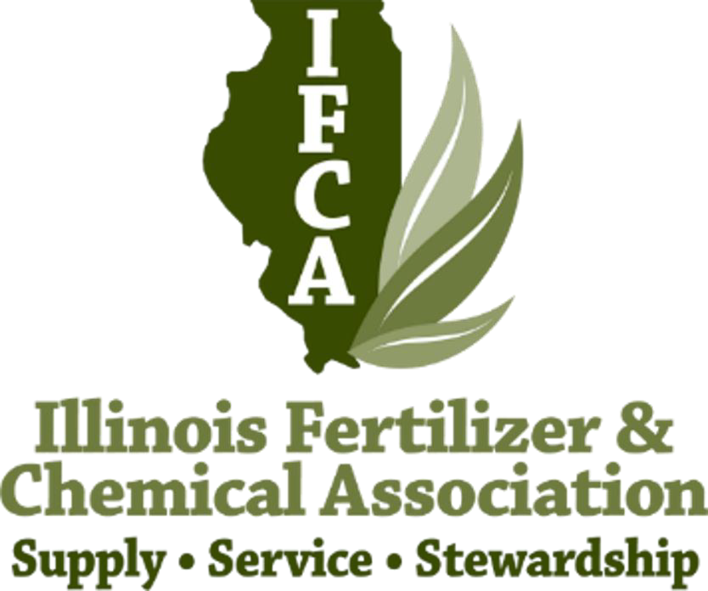
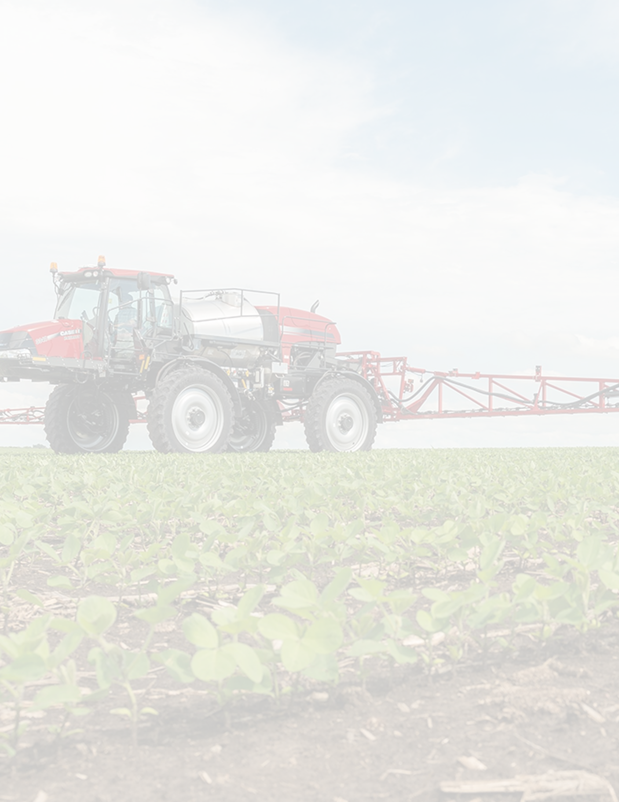

Illinois Fertilizer & Chemical Association Scholarship Application

$1,500.00
Return December 15, 2023 by mail to: IFCA
14171 Carole Drive
Bloomington, IL 61705
Ph (309) 827-2774

Or send via email to Jason Solberg at:
jason@ifca.com

Academic Year 2022-2023

Student Name:

Address to Best Reach You:

CITY STATE ZIP:

Phone Number: Email:

College/University attending: Current GPA

Academic Major/Minor: Expected date of Graduation:

Total College Credit Hours for your curriculum as of end of last completed semester:

Percentage of College expenses provided by:

Parents | Loan | Off or on Campus Job
Merit Scholarship  Need-based scholarship | Summer Jobs  Savings | Other

High School Attended: State

Parents/Guardians:

Hometown of Parents/Guardian:

- How do you envision using your degree after completing your education?

- What are your goals and purpose in pursuing a career in agriculture?

- List any employment positions you have held in an agricultural-related field:

- LIST CLUBS, ORGANIZATIONS, COMMUNITY ACTIVITIES OR OTHER ACTIVITIES OR RESPONSIBILITIES YOU HAVE HAD:

(Use a separate sheet of paper if necessary)

